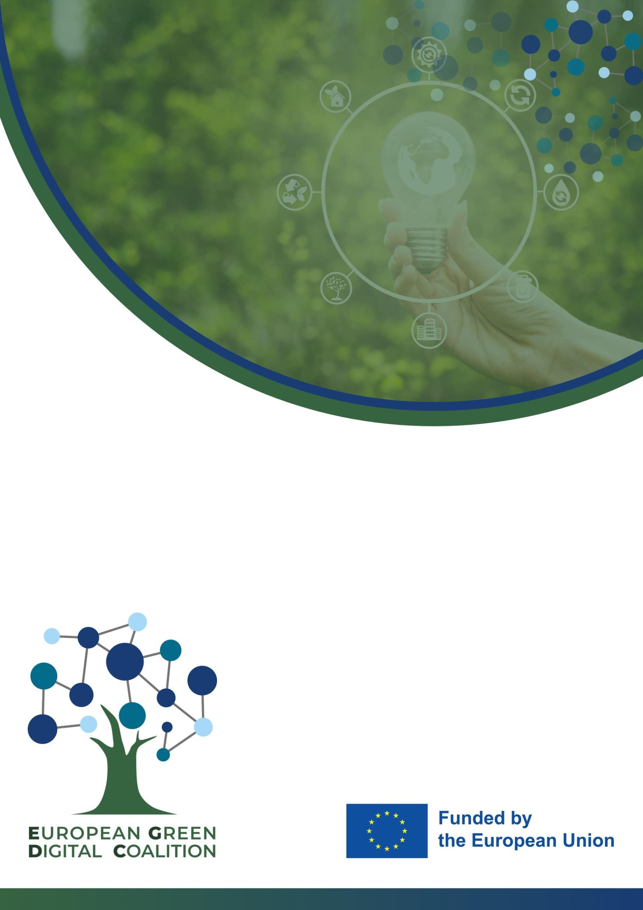

EGDC Supporting Partners

Letter of engagement & Commitment

Scope
  - The EGDC’s main aim is to develop an agreed methodology to measure the net impact of green digital technologies, alongside promoting the deployment of green digital solutions across sectors of the economy and society.
  - In this understanding, Supporting Partners are public or private organisations1 who
actively and voluntarily contribute to the achievement of the objectives of the European Green Digital Coalition (EDGC).
  - Supporting Partners are welcome to publicly identify themselves “EGDC Supporting
Partners” but are required not to imply in their communication they are “EGDC Members”.

Commitments
  - Organisations wishing to become Supporting Partners share the general purpose of the EGDC, which is to support and facilitate the twin digital and green transitions.
  - Supporting Partners recognise the importance of the UN Sustainable Development Goals and – more specifically – declare that they are engaged in activities/programmes to fight against the climate emergency;
  - Supporting Partners commit to collaborate with the EGDC Consortium
Partners and EGDC Members in those activities in which their participation is deemed mutually beneficial and relevant, including:
    - supporting the EGDC Consortium Partners (GeSI, Carbon Trust, and PwC) in their promotion and dissemination activities, promoting the work of the EGDC and its results, e.g. via regular engagement with the EGDC channels.
    - contributing to sharing technical expertise and/or relevant data2 to develop methodologies or guidelines,

  - Supporting Partners are expected to share resources relevant to the work of the EGDC – namely in terms of time of their experts and data – free of charge.

1 e.g. companies, associations, governmental and non–governmental organisations, academia.
2 For example, by submitting relevant use cases for the case study calculators.

  - When sharing data and interacting with the EGDC, Supporting Partners ensure that it is shared in appropriate formats, to ensure that relevant confidentiality, antitrust, and data protection laws are respected.

Benefits
  - Visibility. Organisations that fulfil the conditions to become Supporting Partners, will have the ‘’EGDC Supporting Partner” status on the EGDC website;
  - News & Content. Among the EGDC external parties, the Supporting Partners are those that are entitled to receive first the EGDC updates & news, and that will get an early-bird access to selected EGDC content. Supporting Partners can be involved in the EGDC’s workstreams (see the ‘’Commitments’’ section above) by the EGDC Secretariat;
  - Events & workshops. Upon agreement of the EGDC Secretariat, Supporting Partners might receive exclusive invitations to EGDC events, workshops, etc.

Duration of the engagement
  - Supporting Partners that comply with the abovementioned commitments, are entitled to keep their status until the completion of the EDGC project – provided they continue falling within Scope and respecting the Commitments;
  - Supporting Partners are free to terminate their collaboration with the EGDC at any
time. Any resignation must be made known via email to the EGDC Secretariat. Termination of the Supporting Partners status should be communicated to the EGDC Secretariat with reasonable advance;
  - The EGDC Secretariat may rule the termination of the collaboration with a
Supporting Partner in case of serious infringements of the above-mentioned commitments, or in case of other serious reasons. The EGDC will communicate its decision via email to the Supporting Partner. The termination of the Supporting Partners status will come into force immediately.

Duties of the EGDC Secretariat and Board
  - Requests to become “Supporting Partner” are collected by the EGDC Secretariat, which is in charge of reviewing them;
  - The EGDC Secretariat keeps record of the Supporting Partners and the list shall be
published – and updated regularly – on the EGDC website.

Declaration of commitment
The signing of this document counts as a declaration of commitment to the duties of a supporting partner. The Supporting partner can list below, in which realms they see themselves as being able to support the EGDC project in Phase II.
List of Activities:

The EGDC Secretariat will give direction on which activities the supporting partner can best suited to provide resources/dedicated effort.

The requesting partner acknowledges in full the content of this Engagement Letter and the attached List of commitments

Organisation:
Name of the representative:
Signature:
Date:

* The EGDC Secretariat collects and stores data in compliance with GDPR requirements (Regulation (EU) 2016/679)), and might share those with the European Commission, in compliance with the obligations set out in the Regulation (EU) 2018/1725.

